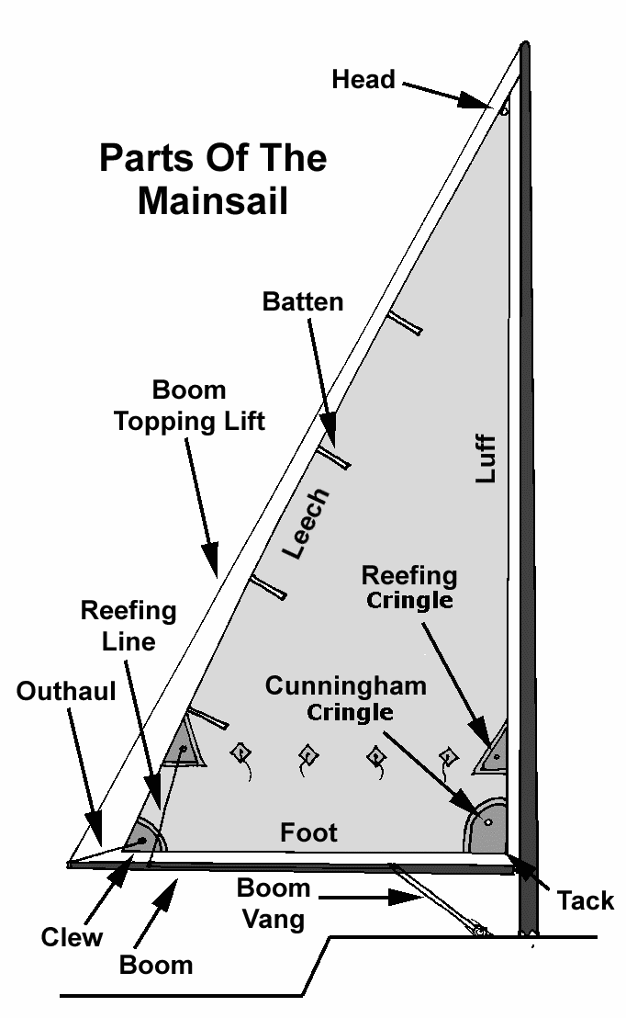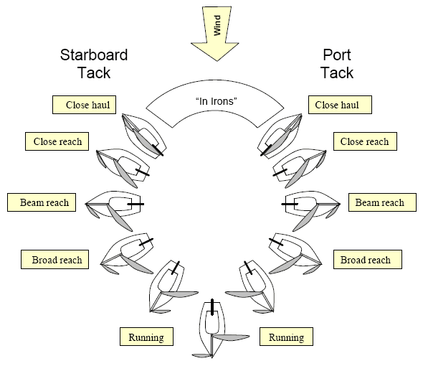
When two sailing vessels are approaching one another, one of them shall keep out of the way of the other as follows:
(a) when each has the wind on a different side, the vessel on the starboard tack has the right of way.
(b) when both have the wind on the same side, the leeward (downwind) vessel has the right of way.
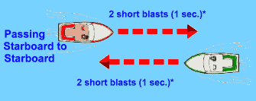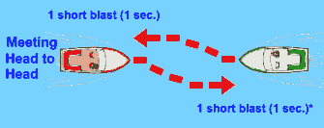  - Three short blasts - I am operating astern propulsion  - Five or more short and rapid blasts - Danger or doubt signal | 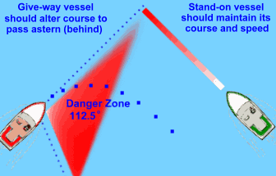  When two power driven vessels are approaching at right angles or nearly so, and risk of collision exists, the vessel on the right is the stand-on vessel and must hold its course and speed. The other vessel, the give-way vessel, shall maneuver to keep clear of the stand-on vessel and shall pass it by its stern. If necessary, slow or stop or reverse until the stand-on vessel is clear.  In the example above, the red vessel is the give-way vessel and should alter course and speed to pass behind the green vessel. If the skipper of the green vessel does not observe the red vessel taking action to avoid collision, then he/she must take the required action to avoid a collision.
 | Running Lights | Masthead Light | Anchor Light
Sail Alone | X
Under Power | X | X
Anchored |  | X | X
FUSES | Amperage
Radio | 6A 250V
Garmin 421 GPS | 3A H 250
Depth Finders (HDR 1 amp, Raytheon 2 amp) | 2 A
Navigation Lights (running, masthead, anchor) | .5 A
Bilge pump / water pump | 3 A
Cabin Lights / Fan | 1.5 A
Autopilot | 12 A
5 Hp Nissan 4 Stroke  3/4 Throttle "Thumbrules" | 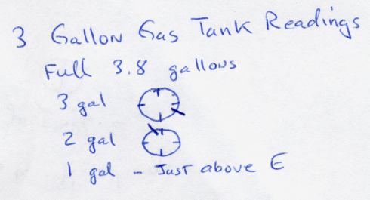
16 miles per gallon
1/3 gallon per hour at 3/4 throttle

Battery Charge Conditions
State of Charge | 12 Volt battery
100% | 12.7
90% | 12.5
80% | 12.42
70% | 12.32
60% | 12.2
50% | 12.06
40% | 11.9
30% | 11.75
20% | 11.58
10% | 11.31
0% | 10.5

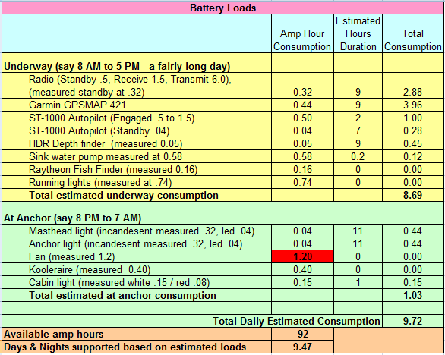
Compass – right set screw adjusts North & South, center set screw adjusts East & West.
TRANSMITTING A MAYDAY* DISTRESS SIGNAL:
- MAYDAY, MAYDAY, MAYDAY
- This is Kerrie Lynne, Kerrie Lynne, Kerrie Lynne
- MAYDAY Kerrie Lynne Position is (Give latitude North and longitude East, or bearing and distance to a well known landmark)
- WE (nature of emergency, taking on water, medical emergency, etc.)
- We Require (assistance required)
- ON BOARD ARE (number adults and children – state condition of any injured)
- Kerrie Lynne is a white 19 foot sloop with blue trim.
- This is Kerrie Lynne. Over
MAYDAY Used when your vessel or life is in grave and imminent danger and immediate assistance is required.
PAN-PAN This is an URGENCY signal used to request assistance in circumstances where the situation is not quite as severe as a MAYDAY situation and though assistance is required it is not required immediately. Typical uses of a PAN-PAN would include non life-threatening medical emergencies and a vessel holed where you were managing to contain the intake of water. PAN-PAN signals take only less priority than MAYDAY signals
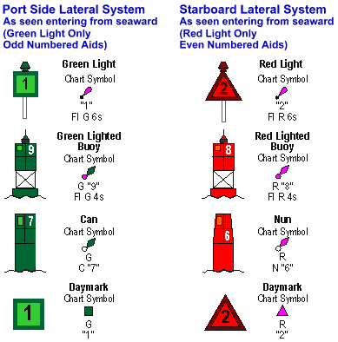
Chart Hydrography Bottom Characteristics:
Blue (bu), Broken (bk;brk), Clay (Cl), Fine (f;fine), Grass (Grs), Gravel (G), Ground (Grd), Grey (gy), Hard (hrd), Mud (M), Oysters (Oys), Rocks/Rocky (Rk;rky), Sand (S), Soft (sft), Shells (Sh), Sticky (stk), Stiff (stf).
